Shap C E Primary School
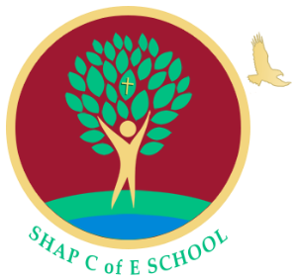
Main Street
Shap
Penrith
Cumbria
CA10 3NL
Telephone 01931 716274
admin@shap.cumbria.sch.uk
www.shap.cumbria.sch.uk

Acting Head Teacher: Mrs. Katie Chappell

“A Safe Branch from Which to Soar”

03 January 2021

Dear Parents and Carers,

Partial reopening only for 9 days: 05-15 January 2021

Partial Reopening

Apologies for writing at this late hour, this is as a result of emergency meetings with our Cluster Schools, members of staff, and members of our Governing Body. We are writing to advise you that in light of the Covid infection rates prevalent in our area, Shap Endowed CE Primary School will only partially re-open, on Tuesday 05 January, to the children of critical workers and for the most vulnerable pupils. From 05 to 15 January inclusive, we will provide home learning (online via Microsoft TEAMS) for all children, to reflect the provision and activities that would have been happening in the classroom.

Cumbria County Council have written to the government this weekend to request partial re-opening for all primary schools. Cumbria Public Health are deeply concerned about the likelihood of further significant transmission of Covid-19, when schools do start. This is due to rapidly increasing cases, currently 571 per 100,000 people in Eden, and 649 per 100,000 in Carlisle. It is also due to the more contagious new strain of the virus, its prevalence among younger age groups, and the fact that North Cumbria NHS’s intensive care capacity is now full.

Unfortunately, the DfE has today refused Cumbria’s request and said schools should fully re-open. Stewart Young, the Leader of Cumbria County Council is quoted today as saying, “this is the wrong decision for Cumbria and for our families and communities… we are concerned… about staff and pupil welfare and safety.” He also stated that, “any school that cannot open the school fully in line with the government instruction will have the full support and backing of Cumbria County Council”.

Following discussions with our Penrith cluster of 10 schools, on the basis of public health advice and local data, and given the experience of schools in our local vicinity, we do not feel that a full primary classroom is a safe workplace at this time, and we do not wish to put our staff, children, families and communities at risk by fully opening our cluster of schools. As a result, Shap CE Primary School, and the other schools in our cluster will not be fully re-opening for the 9 days between 05 – 15 January inclusive. We will review the situation next week, and keep you fully informed.

As discussed in my correspondence earlier today, our ‘on-site’ education will now temporarily be restricted to providing emergency provision for vulnerable children and children of critical workers. Government guidance about these categories can be found on our website here: https://www.shap.cumbria.sch.uk/covid19-pandemic-arrangements/ If you believe your child(ren) are eligible and you would like them to attend school, we ask that you complete the following Microsoft Form (one form per family) before midday on Monday 04 January at the latest: https://forms.office.com/Pages/ResponsePage.aspx?id=sSXetm29NEq0JObzosRpiSczLPhJhzVBk8yW835tfdlUQ1o0RkM4OFA4VlJNRzZFVzJCMVpVMUhZSi4u

To ensure that we can provide both in-school and online home learning, the number of places will be limited. We ask that families only request places if there is no other safe childcare available.

Remote Learning

Your child(ren)’s class teacher(s) will be in contact with you tomorrow afternoon (Monday 05 January) to explain the arrangements that will be put in place to resume home learning via our learning platform (Microsoft Teams)

Updates on Cases and Self-Isolation

If it is identified that your child is required to self-isolate over the coming days, or if there are any positive cases in your household, please can you email school as soon as possible, so that we can be fully informed of the latest situation in the community.

We are very sorry to have to write to you like this at the very end of the holidays, we are doing so because of our wish to keep our, staff, families and wider community safe. Please do not hesitate to contact us if you need to discuss any of your personal circumstances. Thank you for your continued support.

Kind Regards,

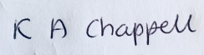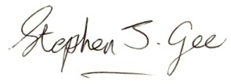
Mrs. Katie Chappell Mr. Stephen Gee
Acting Headteacher Chair of Governors
head@shap.cumbria.sch.uk chair@shap.cumbria.sch.uk

