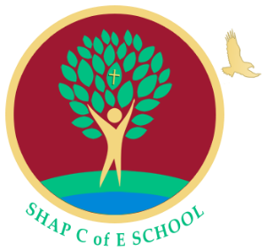
Shap C E Primary School
Main Street
Shap
Penrith
Cumbria
CA10 3NL
Telephone 01931 716274
admin@shap.cumbria.sch.uk
www.shap.cumbria.sch.uk

Acting Head Teacher: Mrs Katie Chappell

“A Safe Branch from Which to Soar”

Wednesday 10th March 2021

Hello Everyone,
Comic Relief – Friday 19th March
Next Friday 19th March, it is Comic Relief and we are really excited to be back at school to be able to participate in it together.
School Council have a busy day planned for you.
Come to school as a superhero: this can be very simple so please do not go out and buy a superhero costume, wear what you have! Get creative by putting some swimming trunks over some leggings and decorating a pillowcase or a piece of material as a cape. This is a £1 donation.
Each class will have a class challenge to complete during the day. Each class will decide on 4 challenges and then the class will vote to see which they do. Some of our ideas are running/biking around the track for a set time, playing playground games as a class for a set time, making music in small groups or how many of different exercises they could do in a minute but we are sure that classes will come up with more.
Decorating biscuits: In our classes we will be decorating a biscuit continuing the superhero theme.
Also, we would like children to complete a challenge at home. This is a creative competition. We would like children to create their own superhero (painting, drawing, model, etc) or write their own superhero story. It is 50p to enter and there are prizes for each class.
In our classes we will be looking at what the money raised is used for so we know who and what we are helping – let see how much we can raise.
Thank you
Coco Wood
School Council

